1 | 04704335 | 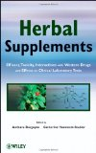 | 9780470433508 | Herbal Supplements: Efficacy, Toxicity, Interactions With Western Drugs, & Effects On Clinical Laboratory Tests | Dasgupta | Caspian | 94.5 | USD | 2011

2 |  | 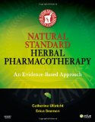 | 9780323051842 | Natural Standard Herbal Pharmacotherapy | Cooper | parsian | 94.5 | USD | 2007

3 | 61210448 | 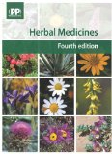 | 9780857110350 | Herbal Medicines 4nd Edition | Pharmaceutical Press | World Arzin Science | 84.15 | GBP | 2013

4 | 61210455 | 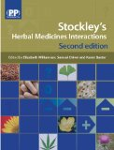 | 9780857110268 | Stockley's Herbal Medicines Interactions: A Guide to the Interactions of Herbal Medicines | Williamson, Elizabet | World Arzin Science | 55.25 | GBP | 2013

